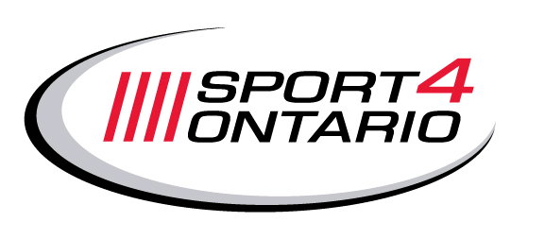
October 26, 2011
We are writing to ask you to write an e-mail to Premier Dalton McGuinty at this website address: https://correspondence.premier.gov.on.ca/en/feedback/feedback.aspx.
Insert your comments into the ‘My message to Dalton’ box and click ‘Send’.
Why we need a Minister of Sport!
Since the provincial Cabinet was announced last Thursday October 20, 2011, no Minister responsible for Sport has been named. The Ministry of Health Promotion and Sport has disappeared. It appears that Health Promotion has gone back into the Ministry of Health and Long-Term Care. The Pan Am Secretariat seems to have gone to the Minister of Citizenship and Immigration. But Sport and Recreation has not been assigned to a Minister. Or perhaps it has. You’ll find Sport on the Ministry of Health and Long-Term Care website under Healthy Living – Pause to Play.
For years, Sport lived in obscurity within the Ontario government. After winning the 2015 Pan/Parapan American Games bid, Sport was added to the Ministry of Health Promotion masthead. It was great cause for celebration! Now it appears that Sport has been relegated to obscurity again. Despite the fact that over 3 million Ontarians (athletes, participants, coaches, officials, staff and volunteers) participate in amateur sport, there is no Minister assigned to lead the programs that affect so many. How will we make the connection with Infrastructure, Tourism, Transportation, Justice, Children & Youth if the branch responsible for Sport is buried in Health?
Which Minister will provide the strategic leadership to leverage the 2015 Pan/Parapan American Games to encourage more Ontarians to be physically active?
Why do I need to take the time to do this?
The Minister responsible for Sport oversees hundreds of grants to provincial sport and multi-sport organizations, recreation organizations, clubs, community centres, etc. These grants support [insert name of your organization]’s programs such [choose the relevant programs for your organization: athlete development such as camps, and competitions, coaching programs, officials training, etc.] Without this valued support, we could be even further behind other provinces such as British Columbia and Quebec who have increased their commitment to sport.
The Minister responsible for Sport also oversees Quest for Gold funding that supports our athletes, coaches and competitive opportunities. Without a Minister responsible for Sport, could this funding be reassigned to some other purpose and not to sport?
Sport and sport sector activities have a significant impact on our economy. According to Rick Traer of the Canadian Sport Tourism Alliance (CSTA) sport travel & tourism account for approximately $1.6 billion of the GDP in Ontario.
Sport needs our own Minister, to fight for our issues and explain to his/her Cabinet colleagues why Sport is important, why our funding is important. We need a Minister who has our back, working with us to tackle the sport sectors’ challenges such as our infrastructure deficit, increasing facility permit fees, financial sustainability, declining volunteer numbers, changing demographics, participation levels and fees, etc.
Who at the Cabinet table will identify the impact that proposals from other Ministries will have on Sport – e.g. Education may decide to kill support to Community Use of Schools—negatively impacting community sport; or the contribution to other Ministries that sport can make—community building, social capital development, and economic impact through sport event hosting.
With an aging population and an obesity crisis we have a perfect storm brewing that has the potential to create overwhelming stress on the healthcare system. The Minister of Health Promotion and Sport provided leadership on the preventative measures for both by increasing physical activity through sport and recreation. Physical activity helps prevent obesity in the younger population while at the same time improves healthy outcomes for seniors. We need a champion, a Minister of Sport!
How can my e-mail help?
Politicians make decisions on the basis of what their constituents say is important. This is a political decision. If Premier McGuinty hears from a lot of people all over Ontario that having a Minister responsible for Sport is important to sport, important to Ontarians, it will happen.
What do I need to do?
Write to the Premier at this website address (just fill in the ‘My message to Dalton’ box, fill in the short form and click ‘send’): https://correspondence.premier.gov.on.ca/en/feedback/feedback.aspx
Your message:
- Who is the Minister responsible for Sport?
- We want our own Minister of Sport, just like Francophone Affairs, Aboriginal Affairs, Women’s Issues and Seniors.
- And we want Sport on the Ministry masthead, just like Culture in the Ministry of Tourism and Culture.
- Tell the Premier anything about how important our sport of <fill in your sport name> is to you, what it has done for you, your kids, your community, Ontario ... say what you like.
But the most important message is “Who is the Minister responsible for Sport?” and “<fill in the name of your sport> wants a Minister of Sport” and “We want Sport on a Ministry masthead.”
Please help. Time is running out.
Send your message to Premier McGuinty at: https://correspondence.premier.gov.on.ca/en/feedback/feedback.aspx
And we also urge you to send the same message to your local MPP. You can find a list of all MPPs here:
http://www.ontla.on.ca/web/members/members_current.do?locale=en
If you have any questions, please contact Ted Gendron at tgendron@sport4ontario.ca.

